Gen PLC Design Document

Table of Contents
1. Introduction
2. Use Cases
3. Architecture Overview
4. Submenu Flows & Flowcharts
5. Functionality & Code Flow (with Screenshots)
6. Testing Strategy & TestSuite
7. Security & Compliance
8. Operational Considerations
9. Appendix: Menu Handler Stubs

1. Introduction
This document specifies the design of the Gen PLC Add‑in and companion console utilities. It covers the intended use cases, high‑level and detailed architecture, control flows for each menu, and a functionality walk‑through augmented with code screenshots.
Scope: The add‑in orchestrates Excel → AWL generation, AWL/XML import into Siemens TIA Portal projects, optional Excel validation and pairing, and downstream testing via Test suite.
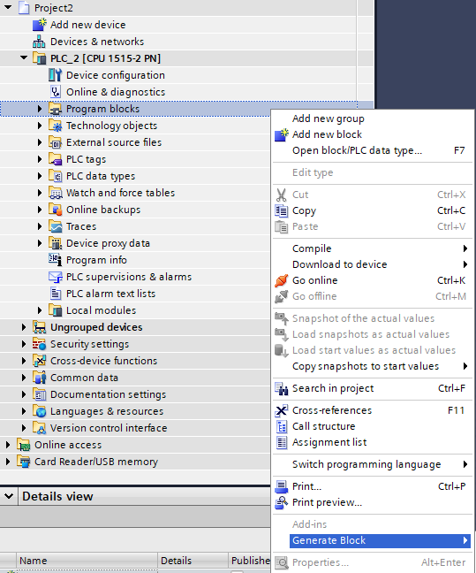

2. Use Cases
UC‑1: Generate from Excel – Engineer selects one or more Excel files; system validates headers/rows, generates AWL, renames blocks using a selectable prefix, imports AWL and XML into the active TIA project, and reports results.
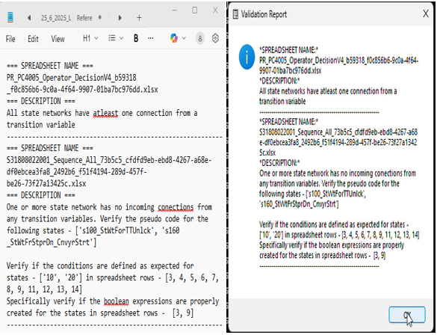
UC‑2: Import AWL – Engineer selects AWL files directly; system backs up any prior user inputs, imports AWL (retrying on transient issues), then imports XML, and reports status.
UC‑3: Import XML – Engineer selects XML files; system backs up prior inputs, imports XML into the correct TIA instance, and reports status.
UC‑4: Excel with Testing – Like UC‑1, then copies the project to a V20 folder and launches exe to run automated tests.
UC‑5: AWL with Testing – Engineer selects AWL and optionally pairs each with Excel for testing; the system imports and then triggers automated tests.
UC‑6: XML with Testing – Engineer selects XML and optionally pairs with Excel for testing; the system imports and then triggers automated tests.

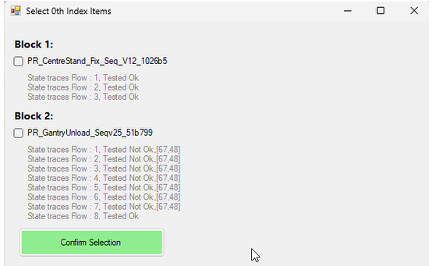
UC‑7: Test Suite – Orchestrates downstream tests (UI automation/compile checks) via exe and aggregates reports. 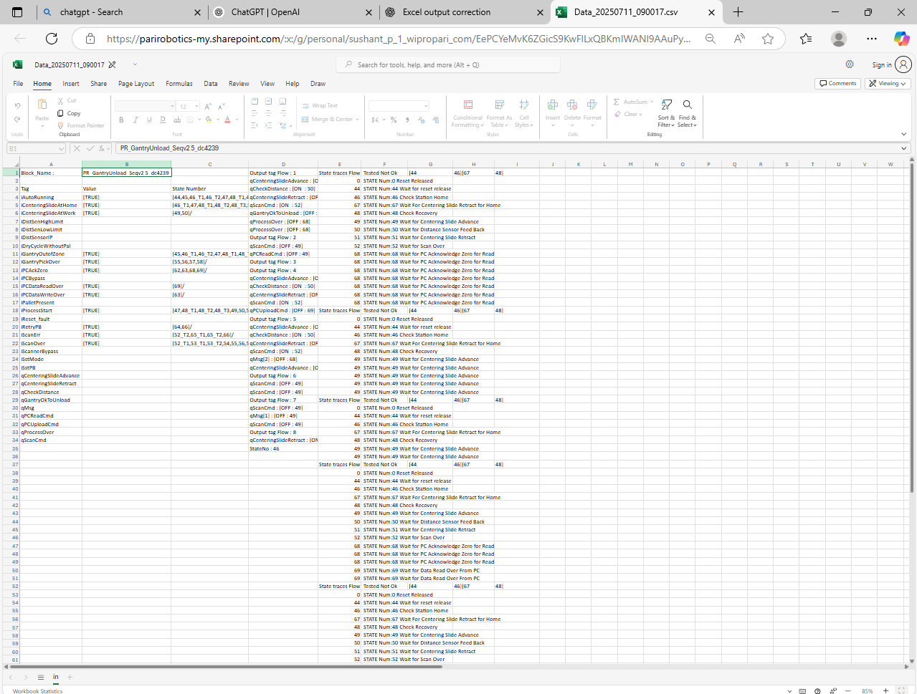

3. Architecture Overview
The solution comprises:
- an Add‑in/UI layer for file selection, pairing, and prompts;
- an Orchestration/Workflow layer that validates inputs, backs up/copies files, and coordinates AWL/XML import;
- an Integration layer with TIA Portal (via Siemens.Engineering APIs) and UI automation libraries (FlaUI, Selenium);
- a Testing/Hand‑off layer that invokes exe to run test routines and capture logs.
- Key external libraries referenced in code include ExcelPackage (EPPlus) for Excel handling, FlaUI/UIA3 for desktop UI automation, OpenQA.Selenium for web UI, and Siemens.Engineering.* for TIA interactions.

4. Submenu Flows & Flowcharts
Each submenu follows a consistent pattern of input selection, validation, backup/copy, import into TIA, and optional test hand‑off. The following flowcharts summarize the control paths.

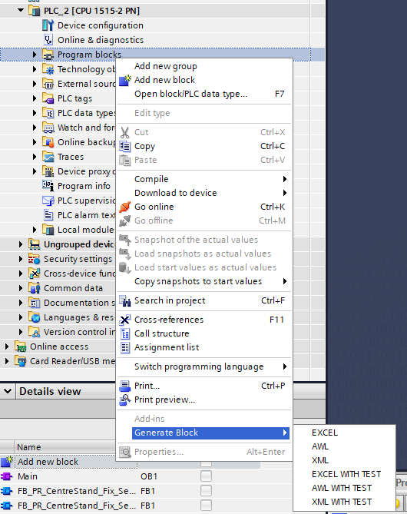

Excel
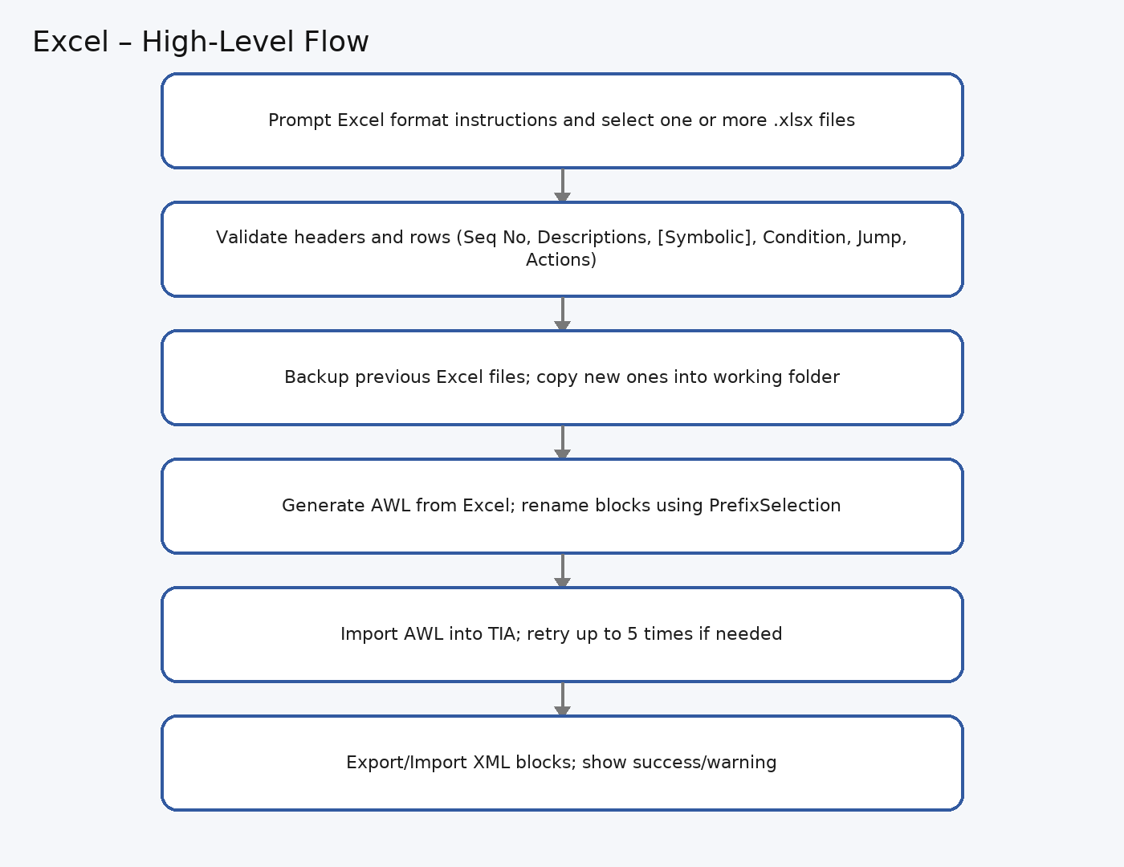
Figure – Excel flow.

AWL
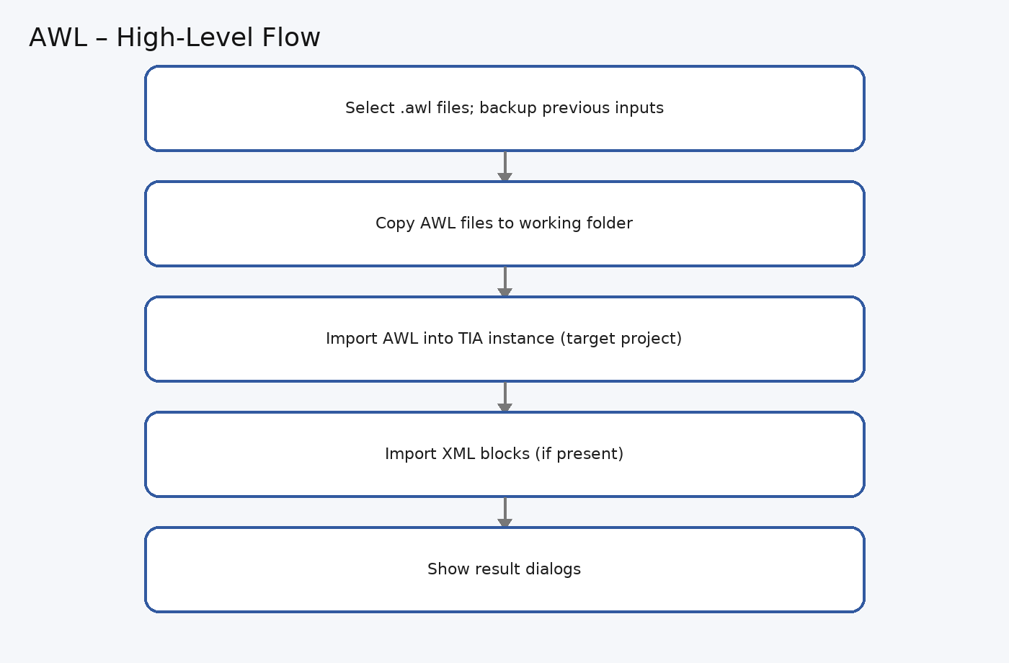
Figure – AWL flow.

XML
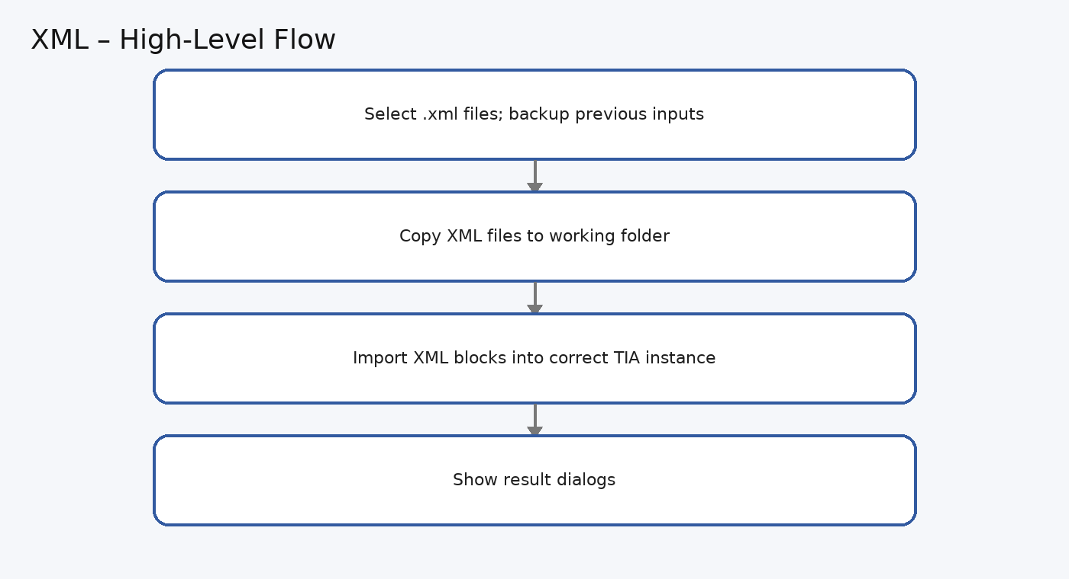
Figure – XML flow.

Excel with Testing
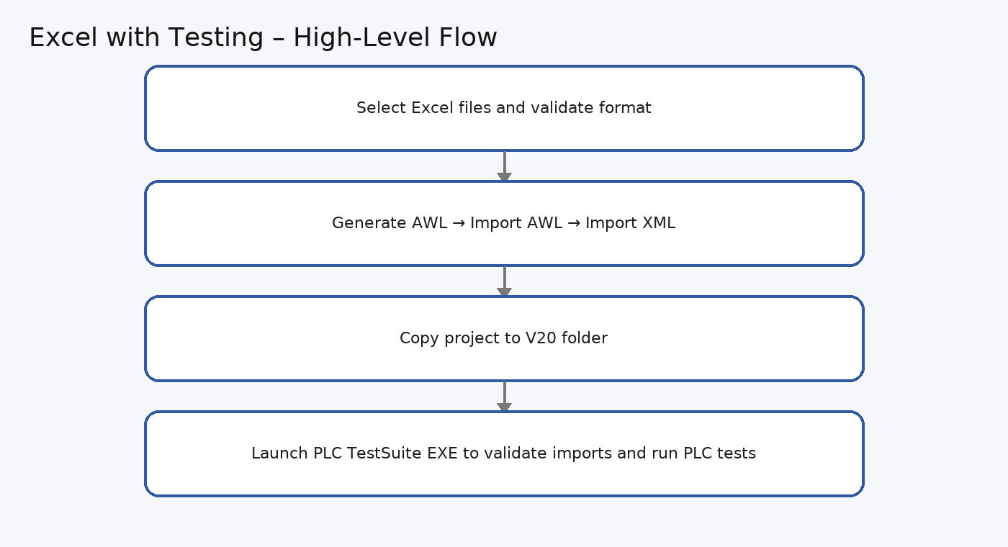
Figure – Excel with Testing flow (with PLC Test Suite EXE).

AWL with Testing
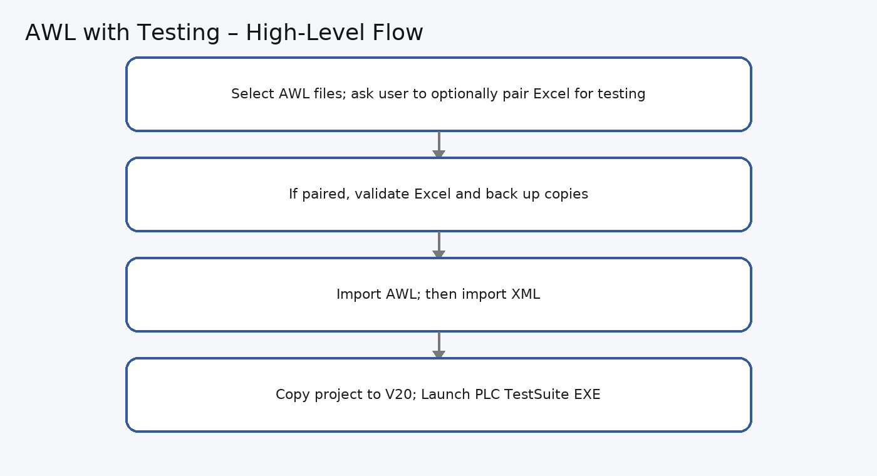
Figure – AWL with Testing flow (with PLC Test Suite EXE).

XML with Testing
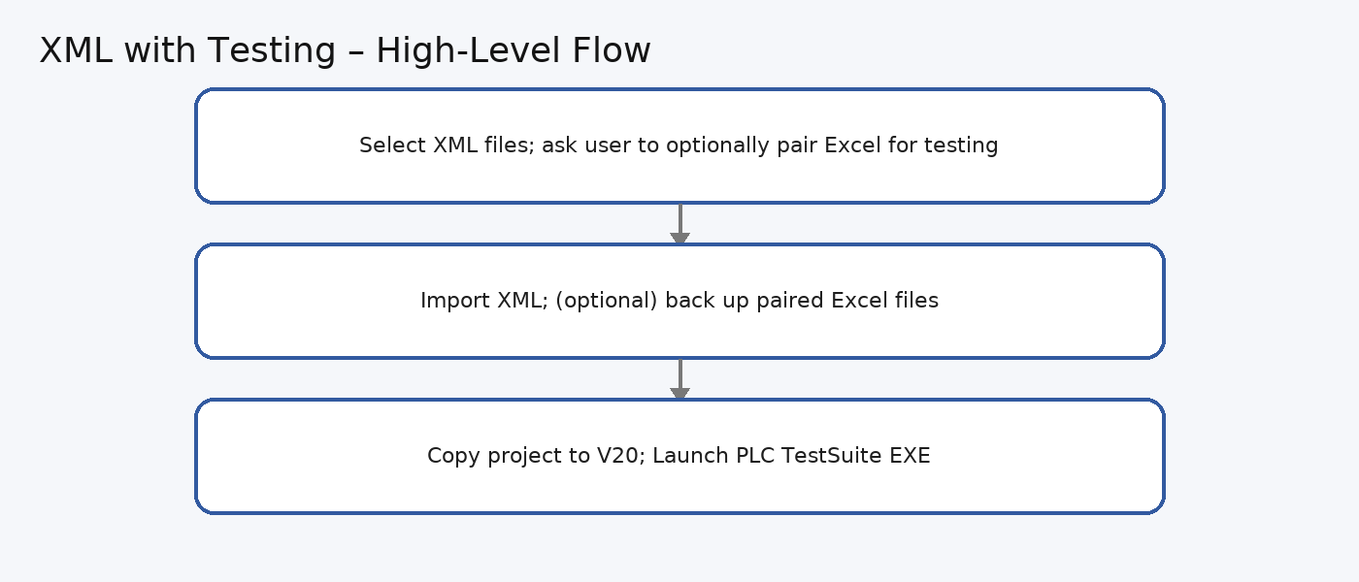
Figure – XML with Testing flow (with PLC Test Suite EXE).

Test Suite
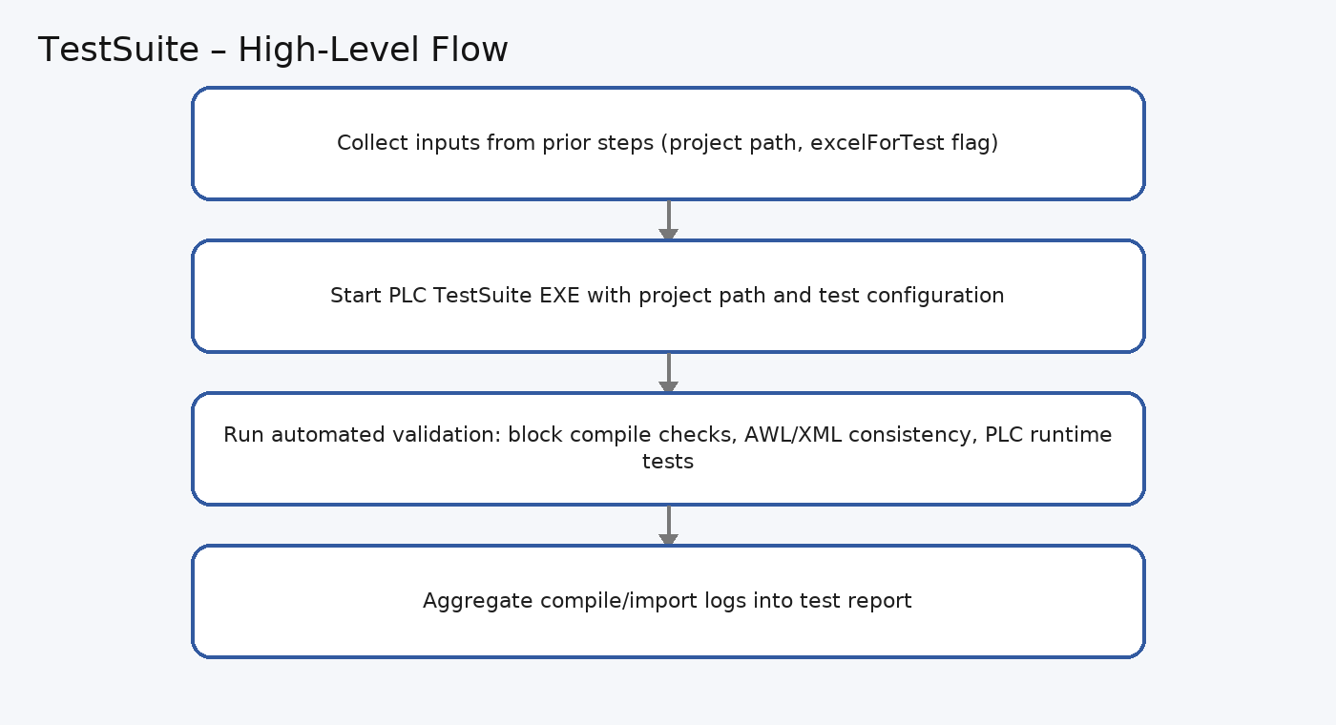
Figure – Test Suite flow (with PLC Test Suite EXE).

5. Functionality & Code Flow (with Screenshots)

The images below are rendered from the provided source to make the core logic. Each screenshot labels the feature and shows the relevant control flow.
- Program Entry Point – Main Method:
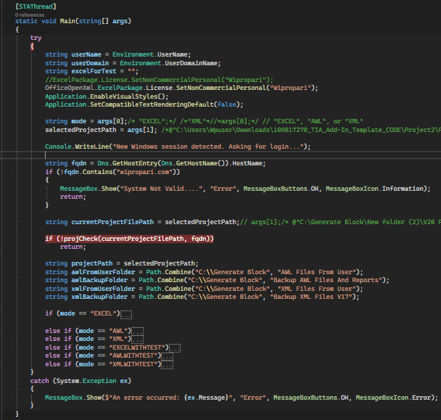
This code represents the entry point of the application, responsible for handling different file-processing modes (EXCEL, AWL, XML, and their corresponding WITHTEST variations). It automates the import and processing of files into TIA Portal projects using Excel, AWL, and XML data sources, while also handling backup, validation, and error management.

Key Functionalities
- Initialization & Environment Validation
  - Retrieves the current Windows user and domain.
  - Ensures execution is within the expected domain (wipropari.com).
  - Loads licensing for OfficeOpenXml (EPPlus) to process Excel files.
  - Initializes WinForms application settings for dialogs and UI prompts.
- Project Path Handling
  - Accepts command-line arguments:
    - args[0] → Mode (EXCEL, AWL, XML, EXCELWITHTEST, etc.)
    - args[1] → Selected TIA Portal Project Path
  - Verifies if the project path is valid before continuing.
- File Mode Operations
Depending on the mode, the application performs different workflows:
  - EXCEL Mode
    - Moves old Excel files into a backup folder.
    - Allows the user to select new Excel files via OpenFileDialog.
    - Validates Excel sheets.
    - Generates AWL files from Excel and imports them into the TIA project.
    - Imports XML blocks for final integration.
    - Displays user-friendly cost estimation and confirmation prompts before block generation.
  - AWL Mode
    - Backs up any existing AWL files.
    - Allows the user to select AWL files for import.
    - Copies them into the project folder and triggers TIA import logic.
    - Completes by importing XML files for validation.
  - XML Mode
    - Backs up existing XML files.
    - Prompts the user to select new XML files.
    - Copies and imports XML into the selected TIA project.
  - EXCELWITHTEST / AWLWITHTEST / XMLWITHTEST Modes
    - Perform the same steps as their normal counterparts, but include:
      - Pairing logic between Excel, AWL, and XML files.
      - Validation of mappings between files.
      - Triggering of test processes (e.g., running PLC/TestSuite validations).
      - Automatic copying of projects into a V20 folder.
      - Launching the next process executable for further testing.
- Backup & Versioning
  - Before moving/copying files, the system creates incremental backups by renaming files with suffixes (_1, _2, etc.) to prevent overwriting.
- Error Handling & Retries
  - Implements retry logic (up to 5 attempts) for AWL file import/compilation.
  - Displays meaningful MessageBox alerts for errors, warnings, or cancellations.
- Integration with TIA Portal & TestSuite
  - Uses helper methods (ImportAwlFiles, ImportXmlFilesFromCorrectTIAInstance, generateAWL, etc.) to interact with TIA Portal and import automation logic.
  - Supports launching follow-up processes for test execution after imports.

- projCheck Method – Purpose & Workflow:

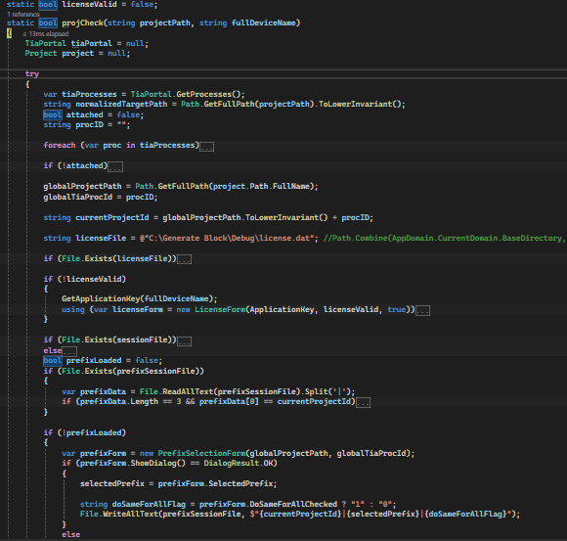

The projCheck method ensures that a valid TIA Portal project is attached and licensed before continuing automation.
Main Functions
- Attach to TIA Portal Project
  - Scans running TIA Portal processes.
  - Attaches to the instance containing the given projectPath.
  - Saves the project path and process ID globally.
- License Validation
  - Checks for an existing license.dat file.
  - Decrypts and validates license (expiry date, format).
  - If invalid/expired, prompts the user via LicenseForm to activate.
- Session Management
  - Uses a session file to track if the same project was already opened.
  - If a different project is opened, forces license re-check/login.
- Prefix Selection
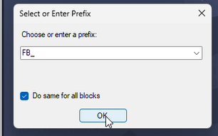
  - Loads previously saved prefix settings from a file (if available).
  - If not found, opens PrefixSelectionForm for user input.
  - Saves chosen prefix and “apply to all” option for future runs.
- Class: LicenseForm :
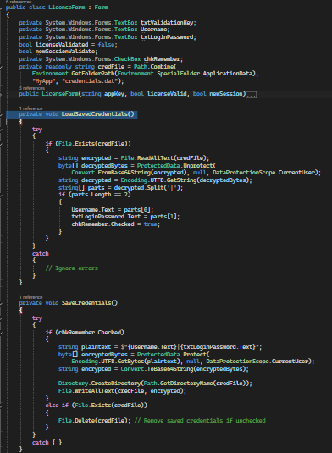
Windows Form for License Verification & User Authentication
Key Features:
- Displays an Application Key (auto-generated from system details).
- Allows entering a Validation Key (generated by Admin).
- Collects Username and Password with show/hide option.
- Provides “Remember Username & Password” feature, storing credentials securely using Windows DPAPI (ProtectedData).
- Automatically loads saved credentials at startup.
- Saves or deletes credentials based on the “Remember Me” checkbox state.

🔑 Application Key Creation
- The Application Key is created on the user’s system.
- It is generated from:
  - MAC Address
  - A fixed identifier string "APL"
  - Device Name
  - System Computer Name
- These values are concatenated, converted to Hexadecimal format, and formatted with dashes for readability.
- Example method:
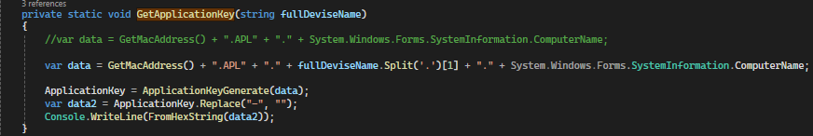The generated Application Key is then sent to the Admin.

🔐 Validation Key Generation (Admin Side)
- Admin uses the Application Key received from the user to generate a Validation Key.
- The Validation Key is derived by:
  - Decoding the Application Key back to plain text.
  - Replacing "APL" with "VAL".
  - Reversing certain string segments to prevent tampering.
  - Re-encoding the data into Hexadecimal with dashes.
- Example method:
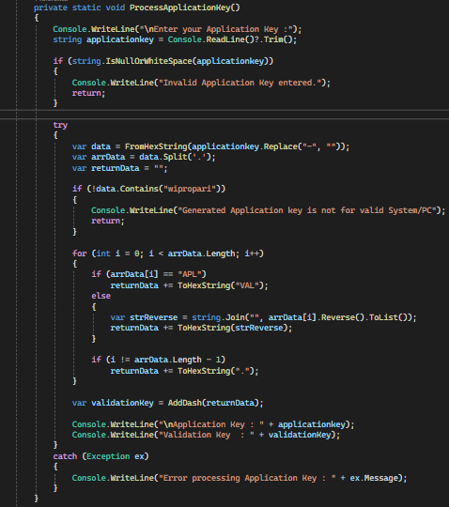
✅ License Verification Flow
- User runs application → Form displays Application Key.
- User sends Application Key to Admin.
- Admin generates Validation Key from Application Key.
- User enters Validation Key into the form.
- System validates the pair using VerifyKey() logic.
  - Ensures "APL" matches "VAL" transformation.
  - Ensures reversed values match original.
- On success, encrypted license (license.dat) is saved locally.

This process ensures:
- Strong device binding (license tied to MAC & system name).
- Tamper resistance (reversing + encoded segments).
- Security (AES + DPAPI for credential storage).
- Ease of use with automated request/response handling via Outlook.

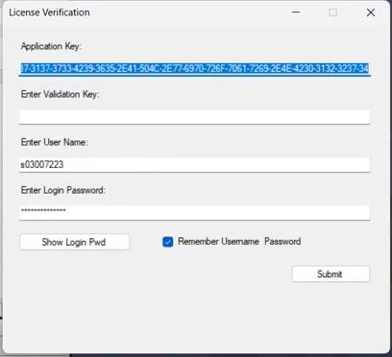
- Submit Button Logic (BtnSubmit_Click) :
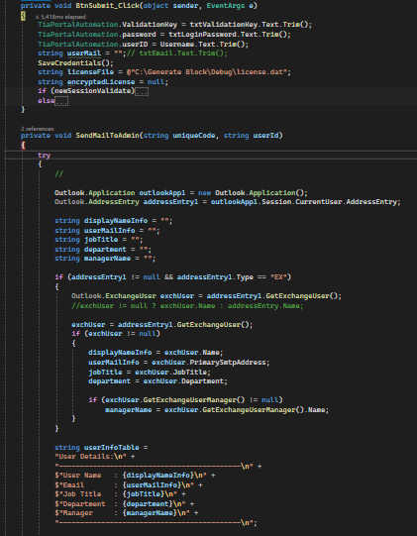
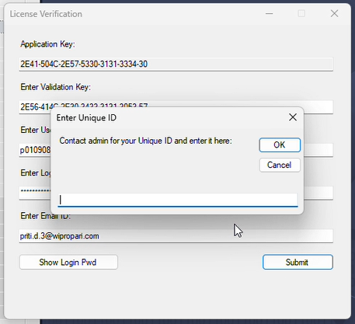
Handles license validation and activation when the user clicks Submit.
Workflow:
- Capture User Input
  - Saves Validation Key, Username, and Password.
  - Stores credentials securely if Remember Me is checked.
- New Session (first-time validation)
  - Verifies entered Validation Key and User.
  - If valid and no active license exists, sends a license request email to admin with user details (via Outlook).
  - Prompts user to enter the admin-provided license key, decrypts and validates it.
  - On success, saves encrypted license locally (license.dat).
- Existing Session (subsequent runs)
  - Reads and decrypts the saved license file.
  - Validates user ID and expiry date.
  - If expired or invalid, requests a new license key from admin.
- SendMailToAdmin()
  - Collects Outlook user details (name, email, job title, department, manager).
  - Sends a formatted license request email to the admin (with CC).
  - Notifies user whether the request was sent successfully.
Purpose:
Ensures secure license activation/renewal by verifying keys and automating the request process through Outlook, while also managing local license storage.
- ValidateExcelSheet (string filePath) Method :
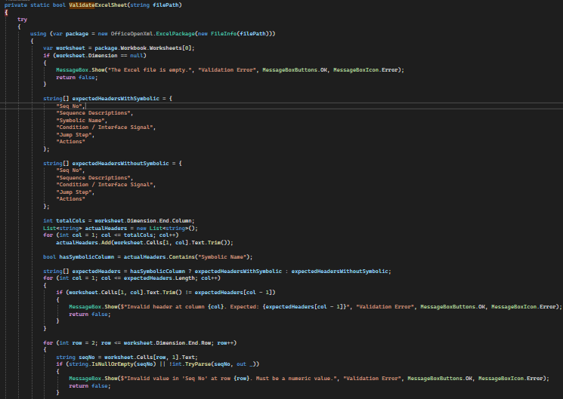
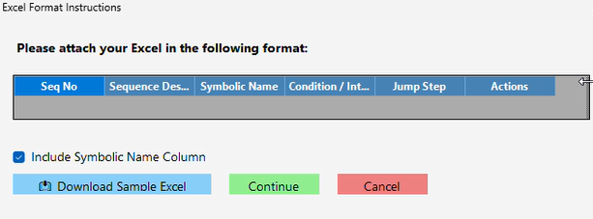
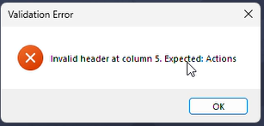
Validates the structure and content of an Excel sheet used for sequence data.
Checks Performed:
- Ensures the sheet is not empty.
- Verifies header names (with or without Symbolic Name column).
- Confirms Seq No is numeric and not empty.
- Ensures Sequence Description is filled.
- If present, validates Symbolic Name is not empty.
- Reads supporting columns (Condition/Signal, Jump Step, Actions).
Purpose:
Guarantees the Excel file follows the expected format and data rules before processing, preventing invalid or incomplete input.
- Block Generation Cost Alert:
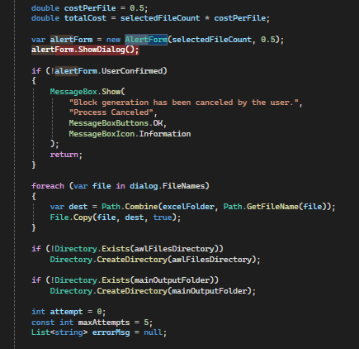
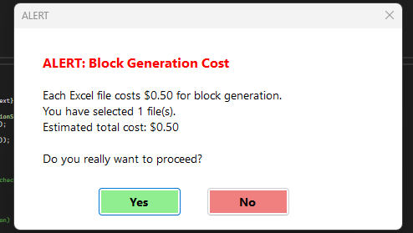
Handles file selection and cost confirmation before processing. It shows an alert with cost details, lets the user confirm, copies selected files into a working folder, ensures required directories exist, and prepares variables for further processing with retry/error handling.
- generateAWL() Method:
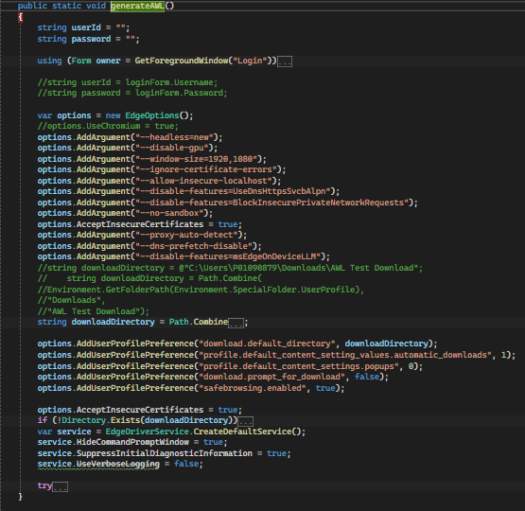
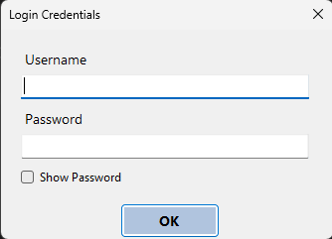
Automates the AWL block generation process by:
- Prompting user login through a custom form.
- Configuring a headless Edge browser with secure download settings.
- Checking and preparing input/output folders.
- Logging into the web application and handling project selection.
- Uploading Excel files and triggering block generation.
- Monitoring upload status and saving results to the designated folder.
Purpose: Provides an end-to-end automated workflow for generating AWL files with minimal user effort.
- MonitorUploadStatus() Method:
Monitors the status of uploaded Excel files in the web application and manages their generated AWL outputs.
Key Steps:
- Creates backup of existing AWL files before new generation.
- Periodically refreshes the page and checks job status in results table.
- On success, automatically downloads reports and AWL files.
- Tracks upload and generation time for logging.
- Compiles validation reports into text files and shows a popup summary.
- Stops once all expected Excel files are processed or timeout occurs.
Purpose:
Ensures every uploaded file is successfully processed, downloaded, logged, and validated with reports for user review.
- ImportAwlFiles() Method:
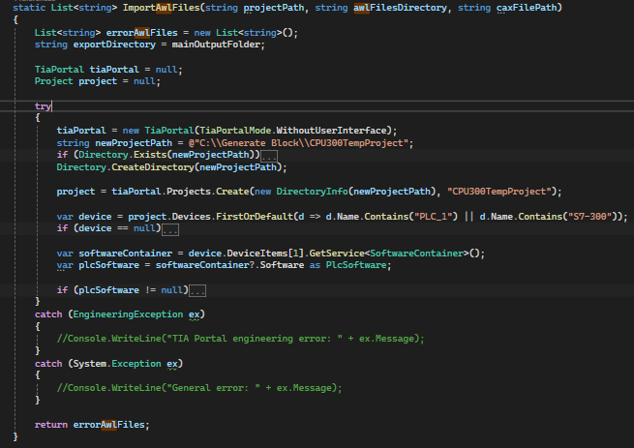
Imports and compiles AWL source files into a temporary Siemens TIA Portal project (CPU 300).
Key Steps:
- Creates a temporary CPU300 project in TIA Portal (with or without UI).
- Adds or creates S7-300 PLC device if missing.
- Imports each .awl file into the PLC program blocks.
- Compiles blocks individually and logs compiler errors if any.
- Saves and reopens the project in UI mode to perform additional actions (like switching block language into LAD).
- Exports all compiled blocks to the output directory.
- Cleans up by disposing TIA Portal, closing processes, and deleting the temporary project folder.
Purpose:
Automates the process of importing, compiling, validating, and exporting AWL blocks in a controlled TIA Portal environment, returning a list of AWL files that failed compilation.

- ImportXmlFilesFromCorrectTIAInstance() Method:
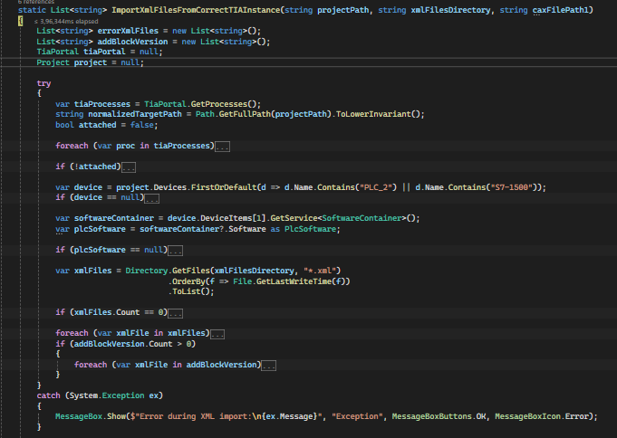
Imports and compiles XML block files into an already open TIA Portal project (CPU 1500).
Key Steps:
- Attaches to an existing TIA Portal process that has the target project open.
- Ensures an S7-1500 PLC device exists (creates one if missing).
- Reads and imports each .xml block file in sequence.
- Handles duplicate blocks by prompting the user to replace or skip.
- Saves backups of imported XML files.
- Compiles imported blocks and logs any compiler errors.
- Optionally updates block versions when user skips replacement.
Purpose:
Automates XML block import into the correct TIA instance, ensuring blocks are integrated, compiled, and backed up while tracking any failures.

- Copy Project in V20 Folder for Further testing in TIA V20:
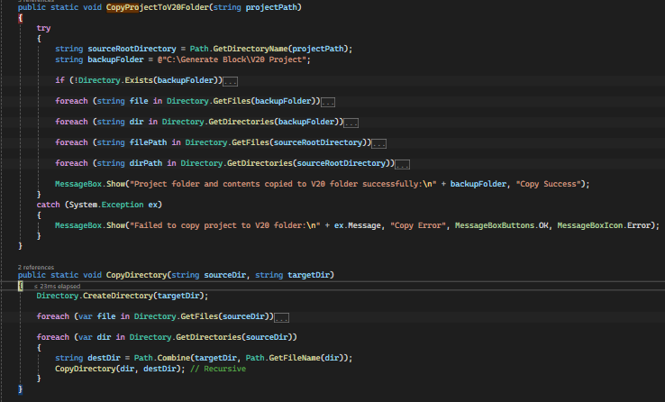
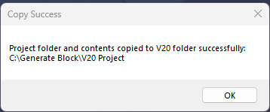
This code provides a safe backup utility for TIA projects:
- CopyProjectToV20Folder → Copies the entire project (files + subfolders) from its original location into C:\Generate Block\V20 Project. It first clears any existing contents in the destination folder, then performs a full copy.
- CopyDirectory → A recursive helper method that ensures all subdirectories and files are copied into the target folder.
In short → It creates a fresh copy of the project in a V20 backup folder for reuse.

- Launching New Exe For Testing using TestSuite :
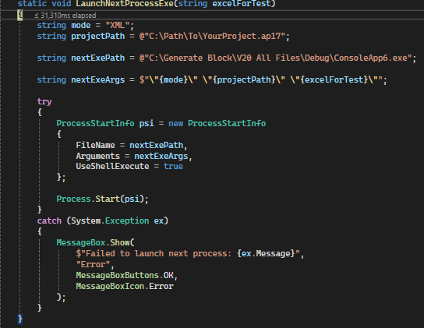
This method launches another EXE file (ConsoleApp6.exe) with parameters.
- It passes project path and Excel file path as arguments.
- Uses ProcessStartInfo to start the external process.
- If launching fails, it shows an error message.
In short: It runs ConsoleApp6.exe with project and Excel file details.

- Auto-Open TIA V17 Project in V20 with Block Selection for Testing :
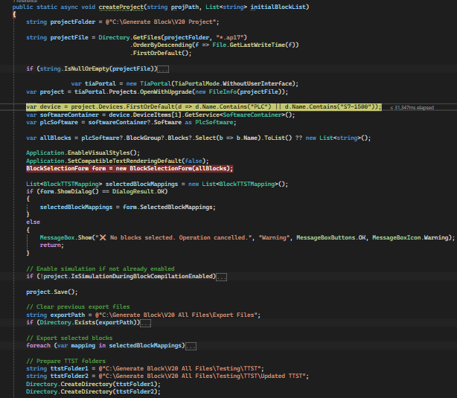
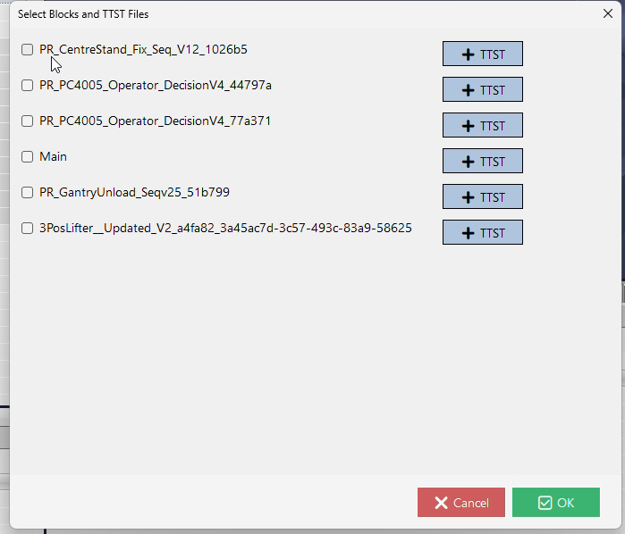
This method automates creating and preparing a TIA Portal project for testing:
- Opens the latest .ap17 project file from the V20 Project folder.
- Detects the PLC device and PLC software inside the project.
- Displays a Block Selection Form so the user can choose which blocks to work with.
- Ensures simulation mode is enabled, then saves the project.
- Clears old export files and exports the selected blocks.
- Prepares TTST test folders and updates .ttst files so each test set matches the selected block names.
In short: It opens a TIA project, lets the user pick blocks, exports them, and select matching TTST and update test files.
- exportblock(Project proj, string blockname, Device dev) Method :
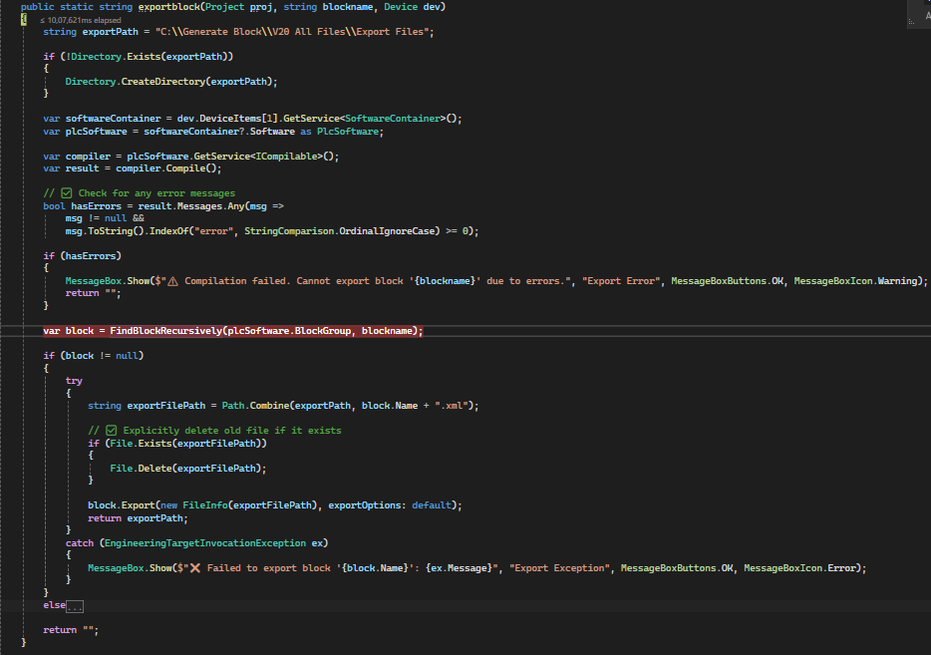
This method compiles the PLC project, checks for errors, and if successful, exports the specified block as an .xml file to the defined export path (C:\Generate Block\V20 All Files\Export Files). It ensures old files are deleted before export and provides error handling with user-friendly messages.

- blockCalling() method:
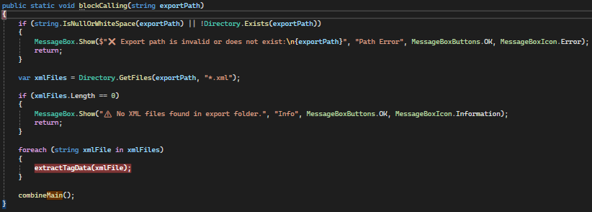
Validates export path, processes all XML files by extracting tag data, and then combines results.
- extractTagData() method:

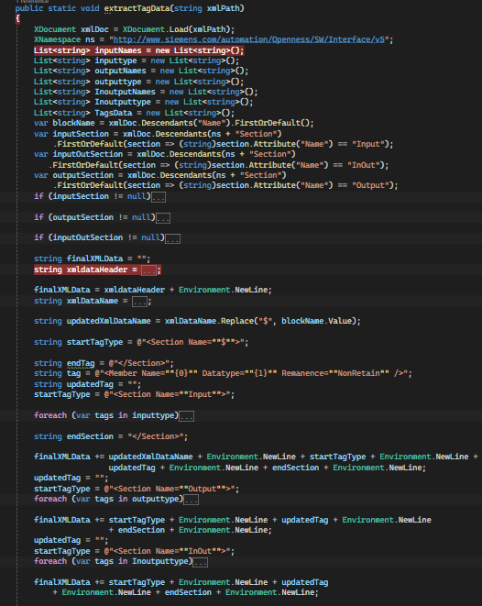
Parses a block’s XML file, extracts Input/Output/InOut tags, generates a corresponding DB XML file, updates mappings, and writes tag data to CSV.
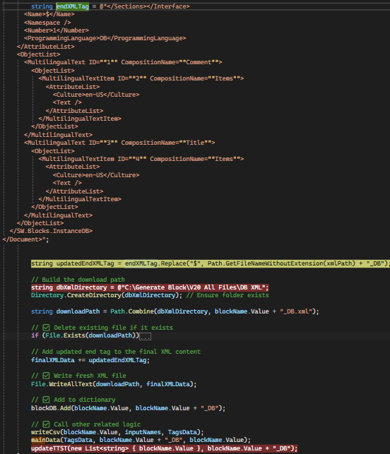This code snippet finalizes the generation of a DB XML file for a TIA Portal block. It updates the XML closing tag by replacing the $ placeholder with the block name (appending _DB), ensures the target directory exists, and saves the fresh XML file at C:\Generate Block\V20 All Files\DB XML. If a file with the same name already exists, it is deleted before writing the new one. After saving, the block name is added to a dictionary (blockDB) and related helper functions (writeCsv and mainData) are called to handle CSV logging and additional processing.
- writeCsv() Method:
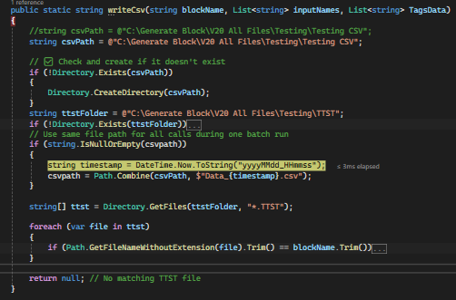
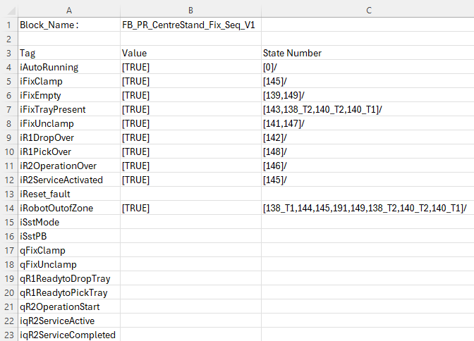
This code snippet finalizes the generation of a DB XML file for a TIA Portal block. It updates the XML closing tag by replacing the $ placeholder with the block name (appending _DB), ensures the target directory exists, and saves the fresh XML file at C:\Generate Block\V20 All Files\DB XML. If a file with the same name already exists, it is deleted before writing the new one. After saving, the block name is added to a dictionary (blockDB) and related helper functions (writeCsv and mainData) are called to handle CSV logging and additional processing.
- updateTTST() Method:
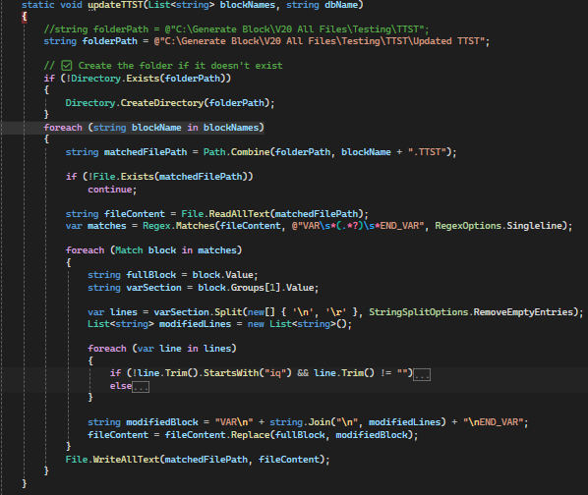
Updates TTST test files by ensuring variable assignments reference the correct DB name, rewriting VAR...END_VAR sections, and saving the modified files back.
- ImportElementAsync() Method:
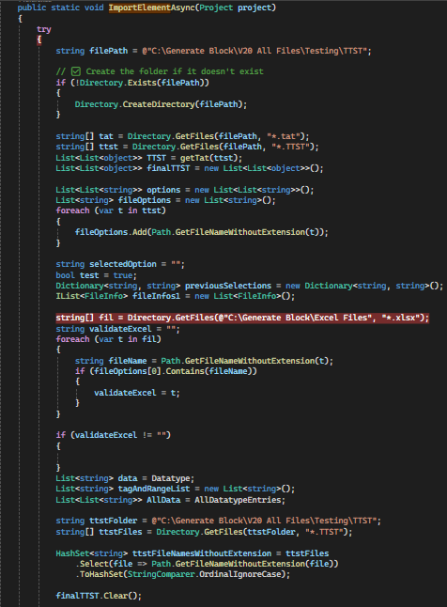
Validates TTST and TAT files, cross-checks them with Excel data, processes tag datatypes and ranges, and opens a selection popup for further testing and filtering of block test data.

- ImportElementAsyncP() Method:

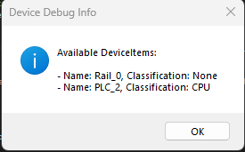
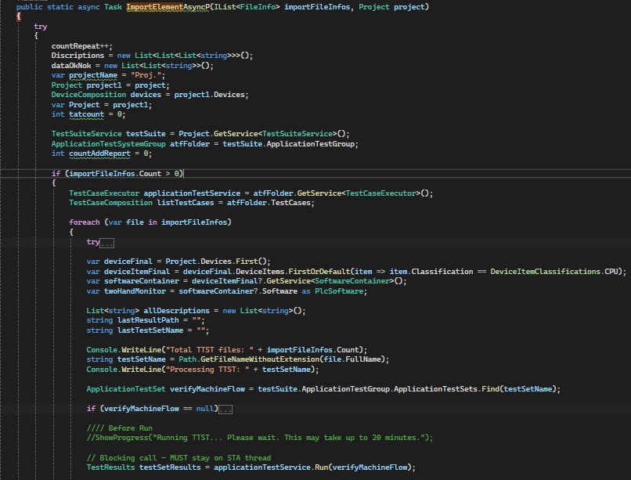

Imports and runs TTST files in TIA Portal, configures PLCSIM for execution, downloads project to virtual PLC, collects test results, and exports consolidated logs and XML reports.

- CleanAnyPlcSimInstance Method () :

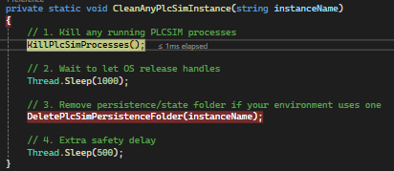

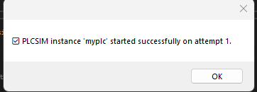
Stops active PLCSIM processes, clears persistence data, and ensures a clean simulator state before reuse.
- PreConfigureDownload () Method:

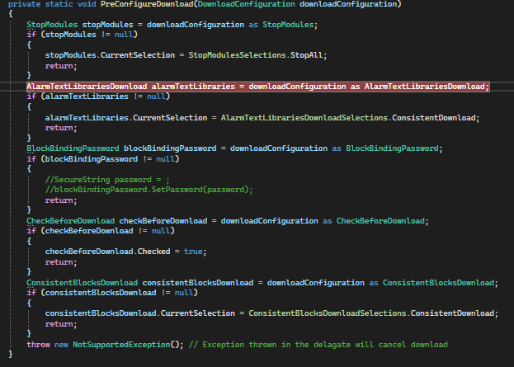

Configures different download options in TIA Portal before starting the download process by setting appropriate selections (e.g., Stop Modules, Alarm Text Libraries, Block Password, Consistency Checks). Throws an exception if the configuration type is unsupported.

- GenerateXMLSelect() Method:

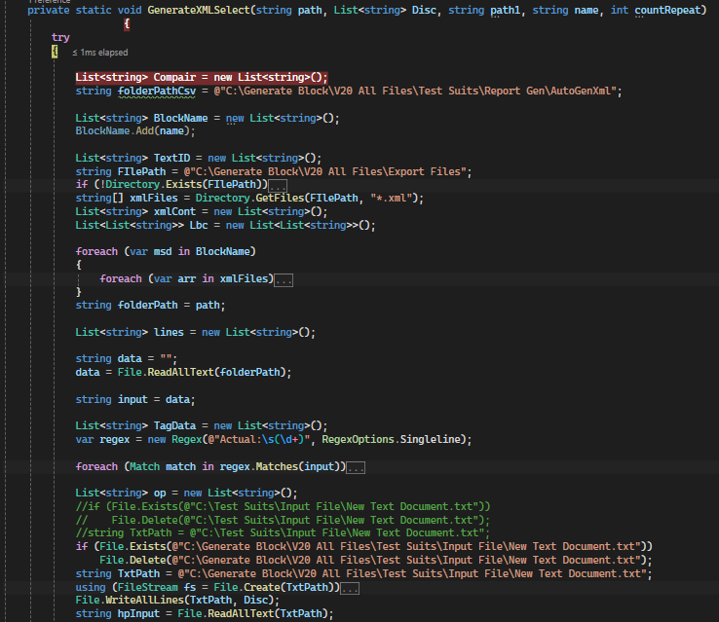
Parses XML and TTST test result data, compares it with Excel reference files, and generates structured descriptions and validation reports. It organizes test flows (state traces and outputs), maps them to expected results, updates CSV logs, and prepares data for automated XML report generation.
- Block Validation and State Trace Report :

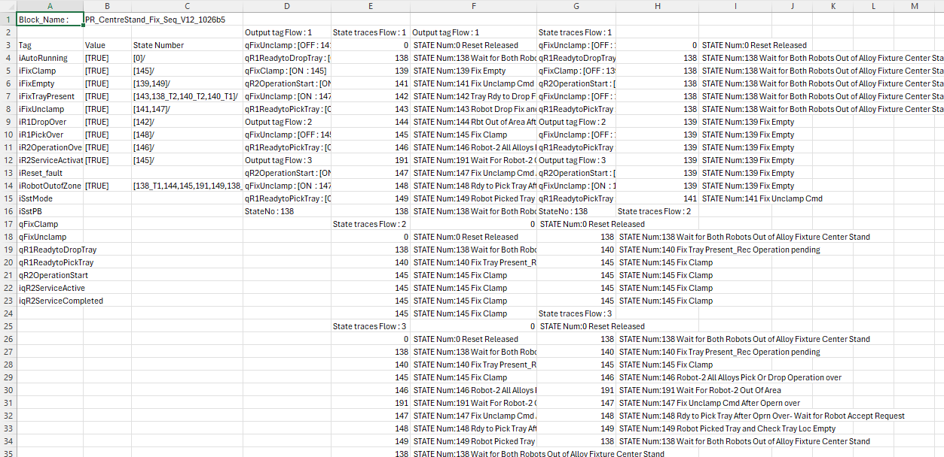

This is the final output in CSV format after all processing is completed.
“The CSV output contains block names, tag values, state numbers, output tags, and state traces across multiple flows, providing a complete log of test execution results.

- Popup for Select Blocks for Further Testing :
This popup allows users to select specific program blocks for further testing. It displays the state trace results (Passed/Failed) for each block and provides a confirmation option to proceed with the chosen items, ensuring only relevant or critical blocks are validated in the next stage.
- Generated Block Testing UI using TestSuite

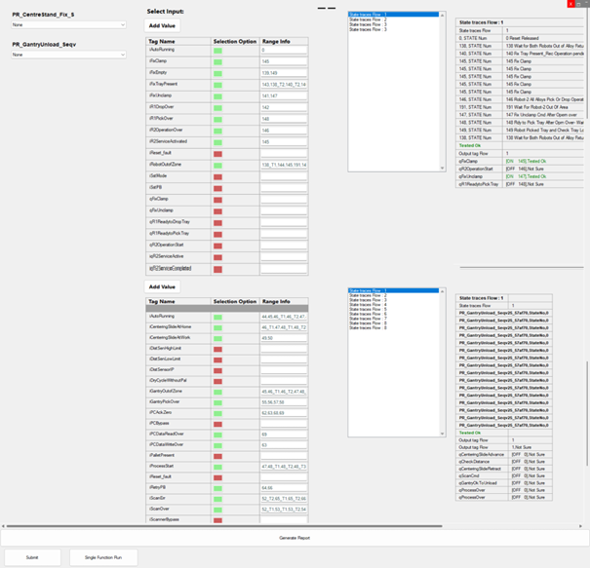

The Generated Block Testing UI provides an interactive interface for verifying block functionality using TestSuite. It allows engineers to select input tags, define test ranges, and observe state trace flows. The tool automates validation, highlights test results, and generates structured reports to ensure block correctness and reliability.

Testing is initiated by Excel/AWL/XML 'with Testing' modes, which copy the project to a V20 folder and launch exe with mode, project path, and flags. The Console app can drive compile checks, import verification, or UI‑level validation using FlaUI/Selenium as required.
Test categories:
- Excel Validation Tests – header conformance, per‑row checks, required fields.
- AWL Import Tests – successful import, retry logic, name prefixing via updateBlockName.
- XML Import Tests – correct TIA instance selection, import completeness, error handling.
- End‑to‑End – Excel→AWL→XML→Compile, log collation, and summary report.

7. Security & Compliance
The code includes an AES helper for simple symmetric encryption of secrets/tokens. Domain validation ensures the add‑in runs in an expected environment. File operations back up user inputs to prevent loss.

8. Operational Considerations

Paths under C:\Generate Block are created on‑demand; previous inputs are versioned by renaming when collisions occur. Retries are used for AWL import to mitigate transient TIA/API/UI states. Dialogs provide positive/negative feedback throughout flows.

9. Appendix: Menu Handler Stubs
Add‑in menu items map to internal modes: EXCEL, AWL, XML, EXCELWITHTEST, AWLWITHTEST, XMLWITHTEST, and a Test Suite hand‑off.
Example: XML WITH TEST handler triggers the external process with arguments derived from the active project path.

